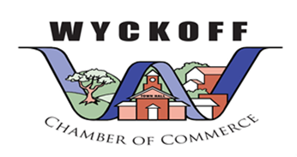

Wyckoff Chamber of commerce Scholarship Awards event!

|  |  |  |
| --- | --- | --- |
|  |  | **You’re invited to join us to reward educational excellence**  **Appetizers will be served so please be sure to RSVP!**  **Join us at Columbia Bank on Tuesday June 2nd, 6:00 pm.** |

**June 2, 2025** – 6:00 pm – RSVP to wyckoffchamber@gmail.com or call 201-468-1999

(303 Franklin Ave., Wyckoff NJ)