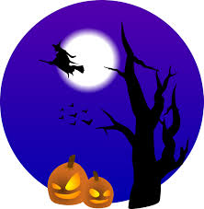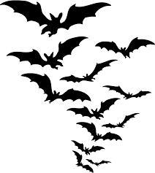
The Wyckoff Chamber of Commerce “Safe Trick or Treat” event
will be held on Saturday, October 26th, 11:00-3:00 pm outside at the Stop & Shop in Boulder Run Shopping Center. Trick or Treat at area businesses, have some special treats and give-a-ways! Get your picture taken by Photography by Cara starting at 11:30 am and posted to Wyckoff Chamber of Commerce Facebook page for you to download.
Come join us and have a spooktacular time!
